CS 346 - Telecommunications and Networks

**LAB 2 - Calculating IP Addresses - Static IP Address Configurations - Prepping to use Wireshark to Analyze Network Traffic**

In this lab we put our knowledge of network addressing to practical use. We are going to calculate information about our current network connection. We’ll calculate our current Network Address, our Broadcast Address and the usable IP address range of the network. We’ll find an unused IP Address within that range and we’ll assign that IP Address as our Linux Server’s static IP Address. As most of us are currently working from home, this lab was written to be easiest to accomplish on a small home or office network that is setup with a basic SOHO router. If you are on a public, corporate, or school network you may want to implement ***Adaptation #1*** as your network administrator might not appreciate you assigning static IP addresses in their DHCP range.

**Prerequisites**

Completion of Lab 1 will prepare you for completing this lab.   
Otherwise you need to do the setup from Lab 1. Reading the Course Textbook Chapter 18.4 (IP Addressing) would be helpful.

**Backing Up a VM**

Throughout these labs we’ll be making configuration changes to our Ubuntu Server installation. It can be easy to break our server, but we don’t have to worry about that, VirtualBox allows us to backup the current state of our server. It’s strongly suggested that you backup your virtual server now. Here are a few online resources that cover this process:

<https://www.youtube.com/watch?v=xqNIvyZlHts>

<https://www.osradar.com/how-to-backup-vms-on-virtualbox/>

**Network Address Calculation**

Our goal is to assign a static IP Address to our server. We need to find an unused IP Address *on the correct network* that to assign to our server. We will need to calculate the range of possible IP Addresses available for our current network. The range of usable addresses are all the addresses that exist in the between the **Network Address** and the **Broadcast Address**. So, we need to be able to find the Network Address,aka **Network Identifier,** and the Broadcast address of the network our computer is currently on. Here are some good articles that cover the calculation of Network & Broadcast Addresses:

<https://www.networkcomputing.com/networking/cisco-networking-basics-ip-addressing>

<https://mycomputernotes.com/network-address-and-broadcast-address/>

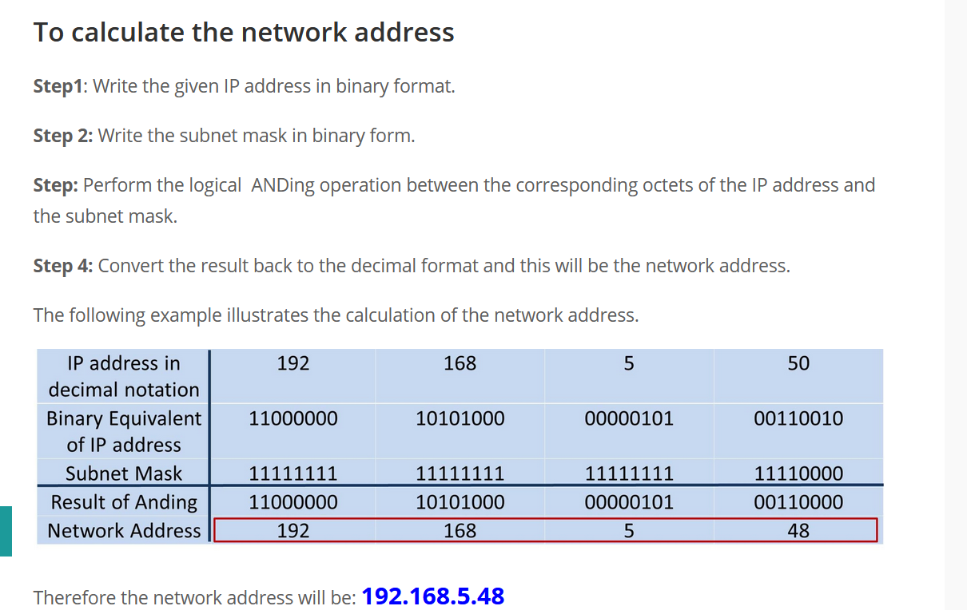

Now that we have our Network Address and our Broadcast Address we know the range of possible IP Addresses available for our network. Our range is defined as every IP Address between the Network & Broadcast Addresses. *Record these values*.  
  
**Static IP Addresses**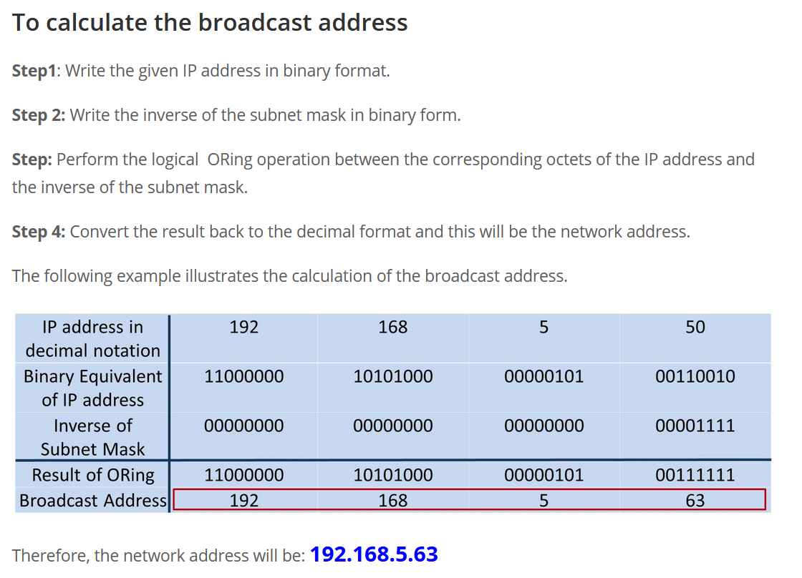

Most Desktop Computers in use today are set up to receive their IP Address from an external machine running the Dynamic Host Control Protocol (DHCP), whereas most servers running today are configured with static IP Addresses. Here are several articles analyzing and explaining differences between these schemes:  
<https://community.fs.com/blog/dhcp-vs-static-ip-differences.html>

<http://www.differencebetween.net/technology/difference-between-dhcp-and-static-ip/>

Here’s an interesting vlog and included blog discussing DHCP vs Static Ip Addresses at a slightly more abstracted level:

<https://www.stephenwagner.com/2019/05/07/static-ip-vs-dhcp-reservation/>

When assigning a static IP Address, you want to avoid assigning an IP Address in the range of IP Addresses your DHCP Server assigns. The article below helps give some understanding how a SOHO router’s DHCP Server works:

<https://stevessmarthomeguide.com/understanding-dhcp-home-networks/>

Now, choose an IP Address in the range you’ve calculated. Run a ping command to that IP Address to see if there is *already* a computer with that IP Address on your current network. On a home network, if nothing responds, it is usually okay to assume that you can use that IP Address. This would be a *bad* assumption to make on a larger network.

Now Assign that IP Address to your Ubuntu Server via the Linux Command line:

<https://www.linuxtechi.com/assign-static-ip-address-ubuntu-20-04-lts/>

Or

<https://www.osradar.com/set-a-static-ip-address-ubuntu-20-04/>

Once you have successfully set up a static Ip Address on your Ubuntu Operating System, your server should be online and able to ping the internet. You should also be able to ping your Ubuntu Server from your host OS.

Servers are often setup with static IP Addresses as they tend to stay in once place, and their network configurations do not often change. However, since most of us are doing these labs on laptops, we will find that our Host OS’s Ip Address often changes. If our VM is in bridged mode, our Static IP Address will not always work when this change happens. You need to decide how you want your server configured. There is a trade-off between static and dynamic IP Addressing. If we use static IP Addressing, and move between networks we will need to re-assign an IP Address to our server every time. However, if we use dynamic addressing, then our Server’s IP Address will change over time. This will cause an issue when we try to connect to the server and don’t know it’s Ip Address. Dynamic DNS services exist to solve this problem. It is a good idea to become familiar with:

<https://stevessmarthomeguide.com/dynamic-dns/>

**Preparing For Future Labs**

Now that we have an idea of how IP Addressing works and how to configure static IP Addresses on our server we are set up for future labs. Soon we’ll be using wireshark to analyze network traffic flowing through our network between our Host OS and Guest OS. To get a head start you might want to look into downloading Wireshark and seeing how you can get it to function.

**Adaption #1**

If you are not on a small or home office network using a basic SOHO router don’t worry, with a few changes you can still accomplish everything in this lab. You’ll need to set your VirtualBox Guest OS up in NAT Mode instead of bridge mode:

* If Your Ubuntu OS is running, shut it down.
* Go to your VM’s Settings:
* 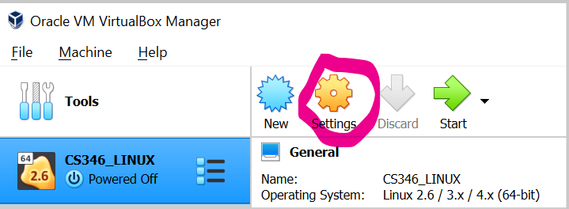
* Under “Adapter”, Choose NAT instead of Bridged.
* 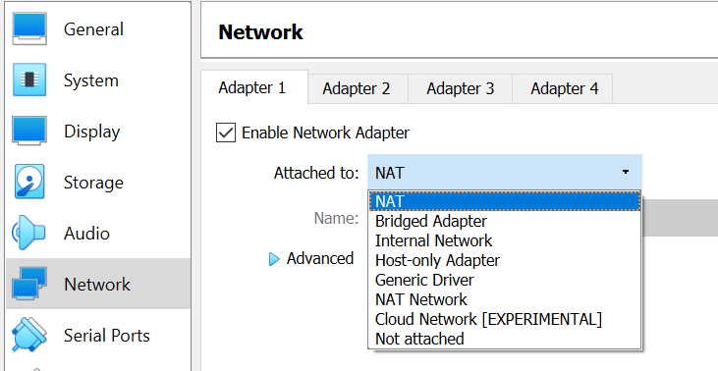
* Now Your Guest OS will be on a special network shared only with your host OS, and your host OS will act like a router to your guest OS. Other Computers on your network will NOT be able to access your server.

**Deliverables:**

Answer The following:

1. What is your current IP Address?
2. What is your current Netmask?
3. What is your current Default Gateway?
4. What is your current Network Address?
5. What is your current Broadcast Address?
6. What is your network's usable address range?
7. What static address did you decide to assign to your server?
8. How many times have you had to install/reinstall Ubuntu 20.04 so far?

**Create a Plaintext File Called *exactly* “cs_346_lab2_[firstName]_[lastName].txt” (example “cs_346_lab2_Adam_Carter.txt”). Answer each question above *on a separate line*. Answer the question *in the order they appear above.* Do not include any text on any line other than the answer. Do not allow any blank lines in your file. When Inputting an IP range, have a hyphen “-” between the two IP Addresses, with *no spaces in the file*. Follow the template given below, then upload it to the LAB 2 Submission on Canvas.**

